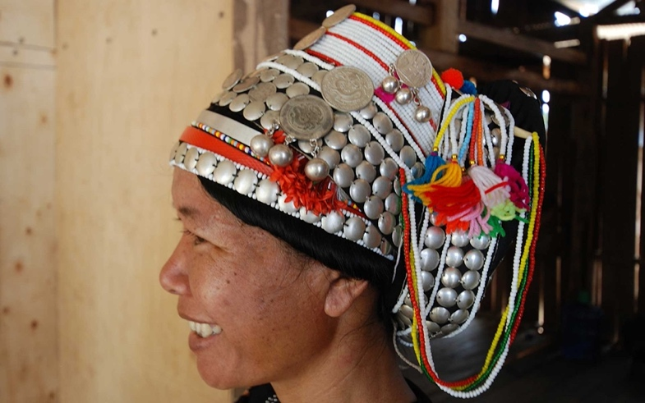
Akha Headdresses
The Akha people are an ethnic group who live in small villages in the mountains of Thailand, Myanmar, Laos, and China. They speak a language called Akha and have their own unique culture. The Akha people are known for their beautiful traditional clothing and ornaments. The women's headdresses are especially elaborate, and each one is unique. The style of the headdress can show where the person is from and their age and social status.
The headdress is made of woven grass fiber and decorated with fur, feathers, and coins. The coins are a sign of wealth and status. The headdresses are very important to the Akha culture. Girls start wearing them when they are teenagers, and they add to them over the years. In the past, women would wear their headdresses every day, even while sleeping. Now, they mainly wear them for special occasions.
The Akha people have a long history and have lived in different countries over the years. Many Akha people have had to leave their homes because of war and conflict. Now, there are about 80,000 Akha people living in Thailand. The Akha people are proud of their culture and their headdresses are a symbol of their identity. They are one of the most recognizable ethnic groups in Southeast Asia. The Akha people are special and unique, just like their beautiful headdresses.

Akha Headdresses

- Where do the Akha people live?

_____________________________________________________________________________________________________________________________________________________________________________________________
Use an orange highlighter to highlight where you found your answer in the text.

- What are the headdresses of the Akha people made of?
_____________________________________________________________________________________________________________________________________________________________________________________________
Use a yellow highlighter to highlight where you found your answer in the text.

- Why are the headdresses important to the Akha culture?
_____________________________________________________________________________________________________________________________________________________________________________________________
Use a green highlighter to highlight where you found your answer in the text.
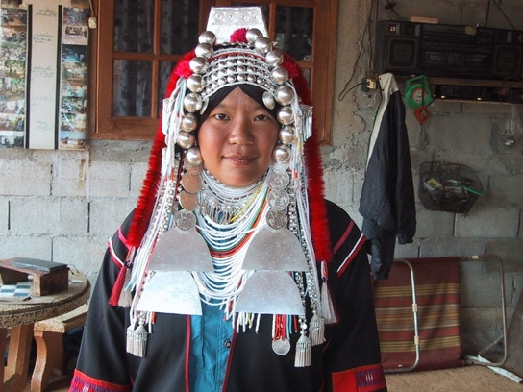
Akha Headdresses
Writing Extension

Directions: Pick one question below and write a response.

1. How do you think the Akha people's headdresses are similar to or different from traditional clothing or accessories in your culture? Use two pieces of evidence from the text to support your answer.
2. Why do you think the Akha people consider their headdresses to be an important part of their culture? Use two pieces of text evidence to support your answer.
3. If you had to choose one item that represents your identity, what would it be and why?
_______________________________________________________________________________________________________________________________________________________________________________________________________________________________________________________________________________________________________________________________________________________________________________________________________________________________________________________________________________________________________________________________________________________________________________________

