Exploring the Practices of El Día de Los Muertos

Introduction
El Día de Los Muertos is a celebration of life and death. Some of its symbols are easily recognizable, such as the calavera, or sugar skull. However, it is often mistakenly compared to Halloween and simplified. This lesson explores some of the lesser known traditions and customs of the holiday to help students gain a better understanding of the practices by those who participate in this celebration. The materials cover the history behind the holiday, in terms of its Mesoamerican and European roots, as well as the growth of the Hispanic population in the U.S., which signifies the growth of attention this holiday deserves in U.S. curriculum.
Indiana Standards Connections:  6.1.2: Describe and compare the beliefs. The spread and the influence of religions throughout Europe and Mesoamerica.  ES.3.1 – Students identify and explore current traditions, rites, and norms of an ethnic or racial group(s) and how they have or are changing over time.  6.1.15 - Examine and explain the outcomes of European colonization as it impacted the Americas including the cultural exchange between Europe and the Americas.  S.2.1 – Define culture and identify the material and non-material components of culture. | Compelling Question(s):  How do cultures celebrate life and death?  How do cultural identities form out of the mixture of cultures and customs?  What are the practices of El Día de Los Muertos? How is it different and so much more than Halloween?
Lesson Objectives:

Students will be able to:
- describe the purposes behind and practices of the Day of the Dead (El Día de los Muertos) celebration.
Materials
- Class Projection Device
- Access to the CLACS Digital Toolbox item: Ornamental Calavera
- YouTube Videos:
  - Dia de Los Muertos: A History
  - Dia de Los Muertos: A Brief Overview
- Museum of International Folk Art - Background Essay (pages 4-8)
- Station materials (attached below)
  - Note: Two of the stations will require a computer/laptop/device to display materials for group
Learning Plan
Activities

- Hook Activity:
  - Begin by showing students the image of the ornamental calavera.
  - Have students discuss in small groups what they notice about the item and from where or from what culture they believe this item originates.
  - Give students some time to discuss in small groups before sharing out.
  - Inform students that this is a calavera, or sugar skull, used during El Día de Los Muertos celebrations.
  - Complete the K and W portions of a KWL Chart about this holiday as a class. You may choose to do one as a whole class (projected) or give students a copy as well.

- Background Info:
  - You may choose to have students read pages 4-8 of the Museum of International Folk Art’s lesson plan (linked above) AND/OR one of the two videos (linked above). The first video is longer and more detailed in its coverage.
  - Inform students to note what new information they learn about the celebration while they read/watch.
  - Discuss what information they have learned about the holiday. Record what they share in the L section of the KWL Chart.
  - For younger and/or struggling students, you may do this all together, pausing the reading or the video to make note of new information.
- Stations Activity:
  - To have students explore more closely some of the attributes of Día de Los Muertos as well as other relevant information, four station activities have been developed and materials prepared.
  - Place students into four groups (if you have a larger class, you may choose to break these down into subgroups and have two subgroups doing a station at a time).
  - Have students rotate through the stations completing the materials for each.
  - Notes about Stations:
    - Station 1: There is a video for students to watch as well as an interactive 360-degree altar for them to explore. There is also a “Compare your answers!” sheet included. You may choose to have the students inform you that they are ready to check their work before giving them this handout.
    - Station 2: You may choose to include some of the lengthier articles about calaveras literarias.
    - Station 4: Two different articles have been adapted for the purpose of this station; one is lengthier and a more difficult read than the other.
- Debrief
  - Have students share out what they learned from the stations. Add anything new to the L section of the KWL Chart.

Assessment Suggestions

Students’ completion of the KWL Chart and the Stations materials serve as assessments. In addition, you could have students complete a separate assessment in which they demonstrate their understanding of the celebration. This could be done in a format such as a one-pager.

Extensions

Students could explore in more depth the history behind some of the traditions, such as the story behind La Catrina (links for resources):
https://www.nationalgeographic.co.uk/history-and-civilisation/2019/10/la-catrina-dark-history-day-deads-immortal-icon
https://www.sfgate.com/mexico/mexicomix/article/La-Catrina-Mexico-s-grande-dame-of-death-2318009.php
as well as All Saints’ Day.

Students could also make comparisons between El Día de Los Muertos and other celebrations of death, such as Ghana funeral practices.

The International Folk Art Museum materials also includes a list of children’s books and other ideas for extended study.

Station 1: Decorating the Altar
Part I: Watch the following video and complete the Guided Notes below.
- The altar must be ready by ________________ because that is when the dead come to visit their loved ones for one night.

- Altars include a variety of items that tell us about the ___________ being celebrated. Items such as _________, __________________, and _____________ are placed on the altar to celebrate those who have __________.

- When building an altar, it is important to keep in mind the four ______________ which are ________, ___________, ____________, and ____________. Only then can the dead and living _________________ through rituals, altar-making, music, dance, and food.

- Many of the celebrations happen at local ______________ including the decorating of altars and the ______________.

- Día de Los Muertos is a ___________ Indigenous celebration. Different Indigenous peoples would build altars for their ____________ and the _____________. Altars welcome _________ during this annual 2-day Indigenous celebration. Post-colonization, this celebration began to have a mixture of pre-Columbian __________________ ritual, _______________, and ____________ culture. Around the world today, you can still see regions and people hold the pre-colonial Indigenous practices. Long ago, people and dancers used caretas, or ___________, to spook the dead away during the end of the festivities. Today, you can see people paint their faces like ___________.

- Día de Los Muertos is not about _____________ death, but it is an opportunity to _____________. It allows many to pass down family traditions and ____________.

- Marigolds, the bright orange or yellow ______________, is known as cempazúchitl in Náhuatl, the Nahua language. It represents the _____________ and it is used to attract the ________ during Día de Los Muertos. They are considered helpful in ________________ deceased family members back into the ______________ world. They are placed on _______________ and tucked behind/into a dancer’s __________.
Part II: Explore this 360-degree video of an altar and answer the following questions.
Adapted from Harvard Peabody Museum Day of the Dead Worksheet
- List some of the objects you see on the ofrenda that are for the spirits of loved ones to enjoy when they return.

- The ofrenda’s shape resembles a pyramid. What might that be?

- Dia de los Muertos is a blend of two religious traditions: Catholicism from Spain and the Indigenous beliefs of the Aztecs. In the chart below, list the following items found on the ofrenda that are from these different traditions.

- Paper flowers (cempazúchitl or marigolds)
- Candelabras
- Angels
- Punched paper banner (papel picado)
- Crosses
- Jesus figure

- Skulls (calaveras)
- Virgin Mary votive candle
- Skeletons

Catholic Tradition | Aztec Tradition

- Describe an object on the ofrenda that demonstrates a blend of these religious traditions and explain the combination.

Compare your Answers!
Part I:
- The altar must be ready by October 31 because that is when the dead come to visit their loved ones for one night.

- Altars include a variety of items that tell us about the person being celebrated. Items such as books, photographs, and jewelry are placed on the altar to celebrate those who have passed.

- When building an altar, it is important to keep in mind the four elements which are fire, water, earth, and wind. Only then can the dead and living reconnect through rituals, altar-making, music, dance, and food.

- Many of the celebrations happen at local cemeteries including the decorating of altars and the gravestones.

- Día de Los Muertos is a pre-Hispanic Indigenous celebration. Different Indigenous peoples would build altars for their gods and the deceased. Altars welcome souls during this annual 2-day Indigenous celebration. Post-colonization, this celebration began to have a mixture of pre-Columbian Mesoamerican ritual, European, and Spanish culture. Around the world today, you can still see regions and people hold the pre-colonial Indigenous practices. Long ago, people and dancers used caretas, or masks, to spook the dead away during the end of the festivities. Today, you can see people paint their faces like skulls.

- Día de los Muertos is not about fearing death, but it is an opportunity to celebrate. It allows many to pass down family traditions and stories.

- Marigolds, the bright orange or yellow flower, is known as cempazúchitl in Náhuatl, the Nahua language. It represents the sun and it is used to attract the souls during Día de Los Muertos. They are considered helpful in guiding deceased family members back into the living world. They are placed on gravestones and tucked behind/into a dancer’s hair.

Part II:
- List some of the objects you see on the ofrenda that are for the spirits of loved ones to enjoy when they return.
Black stuffed animal dog, dog bone, blue toy car, wrestling action figure, wooden top with string, egg collectibles, folding fan, 4-leaf clover good luck charm, card game
- The ofrenda’s shape resembles a pyramid. What might that be?
Pyramids were part of Aztec culture; the sacred mountain, or tepetl in the Aztec Nahuatl language, was used by the community. They were places for religious events and had temples on the top where offerings were made to the Aztec gods. Pyramids were seen as the homes for gods and used as burial places for rulers.
Catholic Tradition | Aztec Tradition
- Candelabras  - Angels  - Crosses  - Jesus figure  - Virgin Mary votive candle | - Paper flowers (cempazúchitl or marigolds)  - Punched paper banner (papel picado)  - Skulls (calaveras)  - Skeleton
- El Día de los Muertos is a blend of two religious traditions: Catholicism from Spain and the Indigenous beliefs of the Aztecs. In the chart below, list the following items found on the ofrenda that are from these different traditions.

- Describe an object on the ofrenda that demonstrates a blend of these religious traditions and explain the combination.
The skull with a crown of flowers on the top center step shows the blending of these cultures. Skulls are Aztec “life-essence containers” and a symbol of rebirth. With the sacrifice comes a new day and a new life for all. The crown references the Catholic “Kingdom of Heaven” or Christ’s crown of thorns.
The ceramic candelabras on the back wall are another item that represents this blend. Candelabras hold candles, which symbolize the soul of a person that prayers are offered for in Spanish Catholic churches. This candelabra is shaped like the “tree of life”, an important symbol in Aztec culture and was also used by early Catholic priests to explain the biblical story of creation. The candelabras also have other Aztec elements: skulls, skeletons, and cempazúchitles.

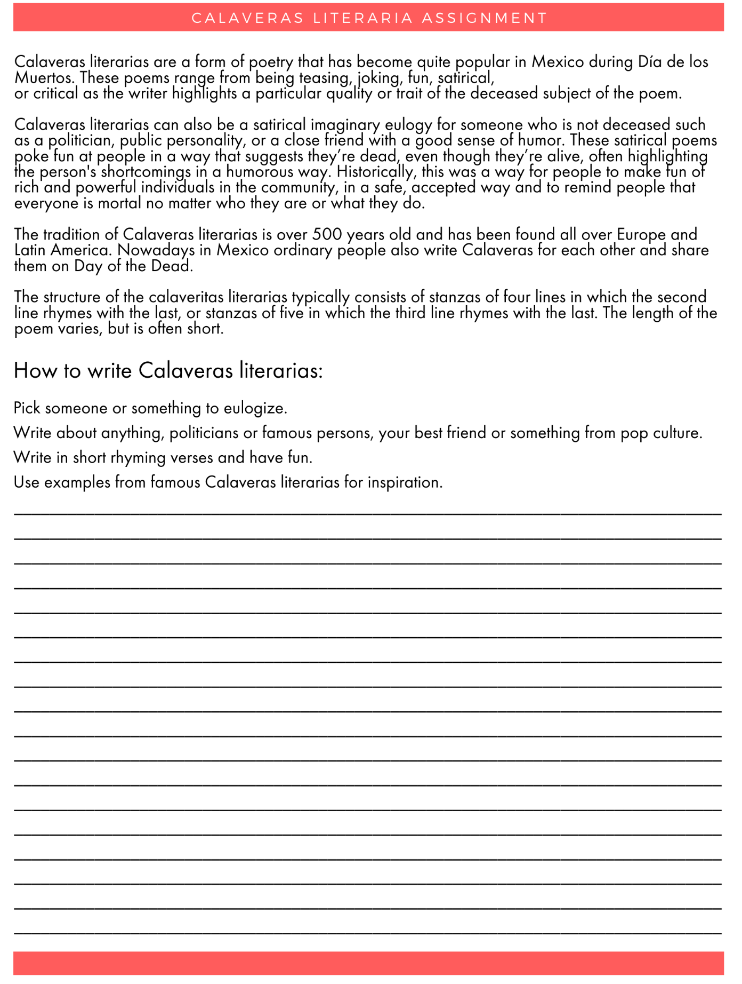
Station 2: Calaveras Literarias
Materials adapted from Day of the Dead Louisville’s El Dia de Los Muertos Lesson Plan
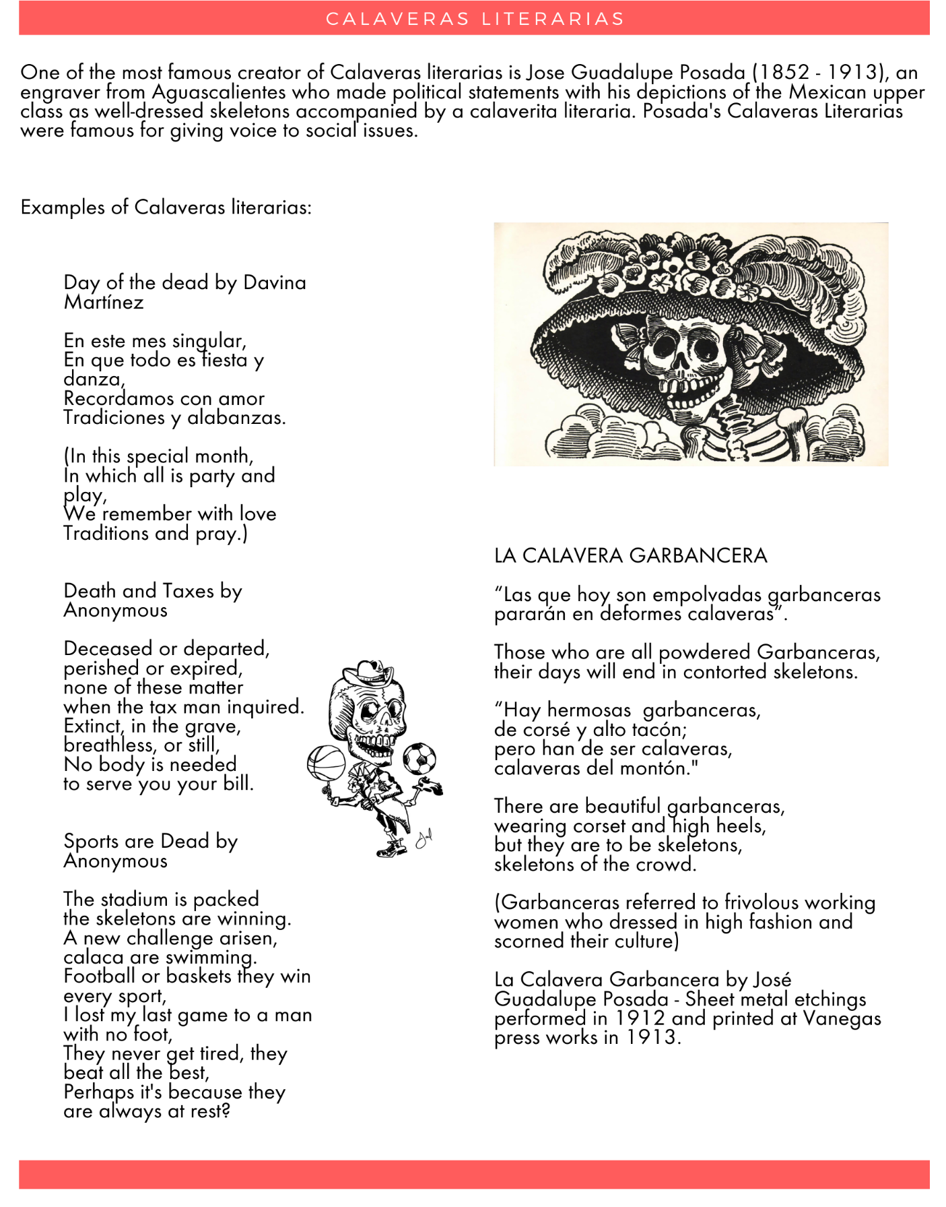

Additional Calaveras Literarias Resources

Worksheet for younger students:
https://www.education.com/worksheet/article/calaveras-literarias/

Articles for reading with older students:
https://rockypoint360.com/literary-calaveras/
https://medium.com/a-mexican-publication/what-is-a-mexican-literary-calavera-77e7a1b5befb
https://www.pbs.org/newshour/arts/poetry/these-wicked-day-of-the-dead-poems-dont-spare-anyone

Station 3: Aztec Myth of Quetzalcoatl
The Day of the Dead celebrations have roots in Aztec, Maya, and Toltec harvest festivals. The tradition of celebrating the dead dates back 3,000 years. In Aztec mythology it is believed that after death, a person's spirit travels to through the 9 levels of the Land of the Dead. After completing challenges in each level the spirit is expected to reach its final resting place, Mictlan (meaning "underworld" in Nahuatl ). If the spirit is unable to complete the challenges it will wander in the Land of the Dead for eternity. These spirits are remembered during Day of the Dead events to connect those in the world of the living and the land of the dead. A popular Mesoamerican creation myth features Quetzalcoatl, an Aztec deity, that saves the human race from the mictlan.
Instructions: Read the myth below. Then answer the questions that follow.
_________________________________________________________________________________
Azted Myth: Quetzalcoatl Rescues Humanity in the Land of the Dead
Posted by Jack Eidt | December 11, 2014 | WilderUtopia
https://wilderutopia.com/traditions/myth/aztec-myth-quetzalcoatl-rescues-humanity-in-the-land-of-the-dead/
Part of the Mesoamerican (Mexica or Aztec) myth of the origin of people, where Quetzalcoatl, the Plumed Serpent, descends into the Land of the Dead, Mictlán, to rescue the bones of humanity and bring them back to life.
Quetzalcoatl’s Descent To Mictlán, the Land of the Dead
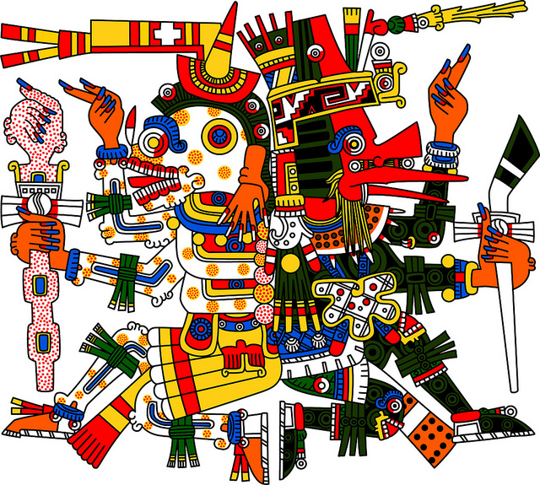
Mictlán is the underworld of the Nahua People (also known as the Aztec, and sometimes as the Mexica Tribe), ruled over by its Lord and Lady. It is a gloomy place, reached by the dead only after wandering for four years beneath the Earth, accompanied by a “soul-companion,” a dog which was customarily cremated with the corpse.
Aztec myth tells how the deity Quetzalcoatl, who in the Nahuatl language means “feathered serpent,” journeyed to Mictlán at the dawning of the Fifth Sun (the present world era), in order to restore humankind to life from the bones of those who had lived in previous eras. For bones are like seeds: everything that dies goes into the Earth, and from it new life is born in the sacred cycle of existence.
Mictlantecuhtli back to back with Quetzalcoatl, based on the Codez Borgia, detail.
Quetzalcoatl and His spirit twin, Xolotl, the god with the serious face of a great hound, said, “I am Xolotl, the Evening Star. Every night, I lead the Sun down to Mictlán to die. I know the way to the Land of the Dead and will guide us there.” Quetzalcoatl, His wise old face wreathed with a beard of brilliant feathers, said, “I am Quetzalcoatl, the Morning Star. Every morning, I lead the Sun back out of Mictlán to be reborn with the dawn. I know the way out of the Land of the Dead and will guide us back home to the sweet paradise Tamoanchan.”
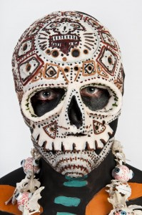
Xolotl led the way down to Mictlán and through the nine layers of the Realm of Death. They retraced the path that the Sun took every night down into the depths of the underworld, all the way to the palace of the Lord of the Dead. “We must be careful,” Quetzalcoatl said. “I know Lord Mictlantecuhtli will not be pleased by our request. He is a wily god and may try to trap us.” Xolotl agreed, and they cautiously proceeded to the throne of the Lord and Lady of the Dead.
Lord Mictlantecuhtli, god of the dead and the king of Mictlan, often depicted with his skeletal jaw open to receive the stars that descend into him during the daytime. From Pink Lady Makeup Artist.
Quetzalcoatl approached the Lord of Mictlán, who sat on his throne surrounded by spiders and owls, as well as the bones of humans, piled up like treasure. “I’ve come for the bones, the precious bones, the jade bones,” said Quetzalcoatl. “Can I have them in order to populate the Earth?”
Mictlantecuhtli frowned, and the chill in the air deepened. “And how do I benefit from this? No, I don’t think I’ll give up my splendid bones. If I give them to you, I’ll never get them back and I’ll be poorer for it. No, you can’t have my bones.”
Quetzalcoatl had anticipated this. “Oh, no! You misunderstand me. We don’t intend to keep the bones, we just want to borrow them. The humans would be mortal, and would eventually return to you, just like how everything else is born and eventually dies, even the Sun itself. Only we Teteo live forever. You wouldn’t really lose anything in the end, and in the meantime, your fame would grow.”
Lady Mictlancihuatl looked pleased by these words. Lord Mictlantecuhtli considered them, then spoke. “Hmmm. An interesting idea. All right. You can have the bones…” Xolotl began to move towards the bones. “IF” continued Mictlantecuhtli. and Xolotl froze. “IF you can play my conch-shell trumpet and circle my kingdom four times in honor of me.” He handed Quetzalcoatl a conch shell that with no finger holes did not look like any kind of instrument. They left the chamber.
Xolotl looked at the trumpet in dismay. The conch shell couldn’t make a sound. “He’s trying to trick us!”
“I’ve got a plan,” said Quetzalcoatl. And he called the worms and other gnawing insects, and ordered them to chew holes into the conch shell. Then he took the shell and held it up, and summoned the bees to climb inside through the holes and buzz loudly. The sound echoed through the shadowy realm like a trumpet blast.
Mictlantecuhtli hid a scowl when Quetzalcoatl and Xolotl marched proudly back into the throne room. “We’ve done what you asked, Lord of the Dead. Now, give us the bones as you agreed!”
“Very well then,” said Mictlantecuhtli, calm again. “You can have them for now. But the humans will not be immortal. They must die again someday and return to me, just as you had said earlier.” The Morning and Evening Star agreed, gathered up the bones, and left.
Lady Mictlancihuatl looked horrified. “Our treasure! We can’t let them carry it off!”
“Of course we won’t. I may have said they could have the bones. I never said they could leave my kingdom with them.” And then he ordered some of his servants to dig a pit along the path that the two gods must take to escape, and others to chase after them.
Meanwhile, Quetzalcoatl knew that he’d better move quickly to take the bones and leave. Quetzalcoatl thought of a trick. “Tell the Lord I’ll leave the bones behind,” he said to his spirit twin Xolotl. Accordingly, Xolotl assured the Lord of Mictlán that the bones would be left. Meanwhile Quetzalcoatl began to run. Unfortunately, he fell into the pit the Lord of Mictlán ordered dug, having been startled by a covey of quail. Those bones that weren’t already shattered were pecked at by the quail. Which is why humans come in all sizes.
“This has not worked out well,” said Quetzalcoatl to his spirit twin.
“What must be must be,” replied the nahual. And so Quetzalcoatl scooped up the bones and, once safely beyond the dead land, ground them up in a bowl. Together with the old goddess Cihuacoatl (Woman Serpent) and other gods, they sprinkled them with their blood, restoring them to life. And thus humankind was born from the penance of the gods themselves.
Based on the Myth of the Suns and the Toltec-Chichimec Origins of the Mexica People, as translated by Willard Gingerich, in The Flayed God. by Roberta H. and Peter T. Markman, blended with the variant as told by Cehualli.

Questions:
- What does this myth represent or explain for the Aztec people and their descendants?
- How does this myth demonstrate the importance of the afterlife for the Aztec and their descendants?
- Why would this myth be an important part of the celebrations of El Día de Los Muertos?

Station 4: U.S. Hispanic Population
Instructions: Use the following materials to answer the questions that follow.
A Brief Statistical Portrait of U.S. Hispanics
By Cary Funk and Mark Hugo Lopez | June 14, 2022 | Pew Research Center
https://www.pewresearch.org/science/2022/06/14/a-brief-statistical-portrait-of-u-s-hispanics/
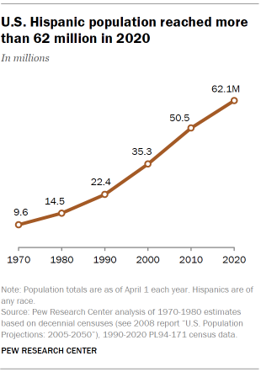
The U.S. Hispanic population reached 62.1 million in 2020, accounting for 19% of all Americans and making it the nation’s second largest racial or ethnic group, behind White Americans and ahead of Black Americans, according to the U.S. Census Bureau. It is also one of the fastest growing groups in the U.S. Between 2010 and 2020, the country’s Hispanic population grew 23%, up from 50.5 million in 2010 (the Asian population grew faster over the same decade). Since 1970, when Hispanics made up 5% of the U.S. population and numbered 9.6 million, the Hispanic population has grown more than sixfold.

Latinos are reshaping national and state-level demographics
With such sizable and rapid growth, U.S. Latinos have shaped the nation’s demographic story for several decades. From 2010 to 2020, they accounted for about half of U.S. population growth, a pattern continued from 2000 to 2010. As a result, the Latino population has grown in just about every corner of the nation. Today, while California, Texas and Florida hold about half of the U.S. Latino population, the fastest growth rates are in states such as North Dakota (up 148% between 2010 and 2020) and South Dakota (up 75% over the same period).
Growing Hispanic populations are also reshaping the demographics of states. In the last decade, Hispanics became the largest racial or ethnic group in California for the first time. California joins New Mexico as the two U.S. states where Hispanics are the largest racial or ethnic group. And the future demographics of many states are poised to be further shaped by Hispanics. In 2000, in eight states, 20% or more of kindergartners were Hispanics. By 2017, that number had grown to 18 states plus the District of Columbia.

The diverse origins of U.S. Hispanics
Hispanics are a diverse group with deep roots in Latin America. In 2019, 61.5% of all Hispanics indicated they were of Mexican origin – either they were born in Mexico or traced their ancestor’s roots to Mexico, according to Center analysis of U.S. Census Bureau data. At 37.2 million people in 2019, this makes the Mexican origin population the largest among U.S. Hispanics.
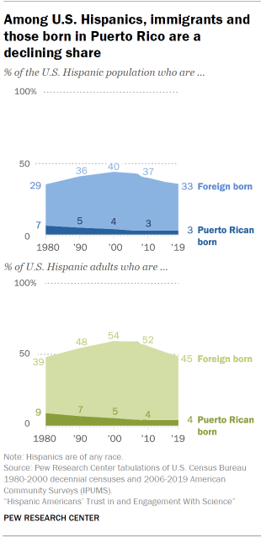
The next largest group is Latinos of Puerto Rican origin – those born either in Puerto Rico or who trace their family’s roots to Puerto Rico. Puerto Ricans account for 9.7% of the U.S. Latino population. Cubans, Salvadorans, Dominicans, Guatemalans, Colombians and Hondurans all round out the largest groups, each with a population of a million or more in 2019.
At the same time, the origins of Hispanics have been changing. Between 2010 and 2019, the fastest growing origin groups were Venezuelans (up 126%), Guatemalans (up 49%) and Hondurans (up 47%). By comparison, the Mexican population grew just 13% over the same period, and the Ecuadorian population grew the slowest, just 6% between 2010 and 2019.

U.S. born Latinos comprise a majority, immigrants make up a declining share of U.S. Latinos today
In 2019, about 19.8 million, or one-third, of all Latinos living in the U.S. were born outside the country, and an additional 1.9 million, or 3%, were born in Puerto Rico (those born in Puerto Rico are U.S. citizens at birth). Both groups have seen an increase in their population numbers since 2010. The number of Latino immigrants living in the U.S. was up from 19 million in 2010, and the number of Puerto Rican-born Latinos living in the U.S. was up from 1.5 million.
But, the share of U.S. Latinos born in another country peaked at 40% in 2000, and has declined since then, reflecting a slowdown in immigration from Latin America since then. Among Latino adults, the share born in another country stood at 44.8% in 2019, down from a peak of 55% in 2007.
The share of U.S. Latinos who were born in Puerto Rico is falling too, though it has rebounded some with increases in out-migration from the island following Hurricanes Maria and Irma in 2017. In 1960, the Puerto Rican-born share among U.S. Latinos peaked at 11%, but has since settled at around 3% since 2010.
Across Hispanic origin groups, the share born outside the U.S. varies widely. Venezuelans have the highest immigrant share, at 77%, followed by Paraguayans at 65% and Hondurans at 63%. But notably, across all groups except Venezuelans and Spaniards, the immigrant share has been in decline over the last decade as the Hispanic population becomes more settled.
At the same time, the number of Hispanics born in the U.S. has grown. Their share of the Hispanic population has risen too, from 59.9% in 2000 to 67.3% in 2019. This reflects the greater contribution to Hispanic population growth of births in the U.S. to Hispanic parents compared with the arrival of new immigrants, a trend that has become more pronounced in the last decade. Among adult Hispanics, the U.S.-born share increased, from its recent low of 45% in 2007 to 55.2% in 2019.

A growing share of Latinos are English proficient
English proficiency is rising among U.S. Latinos. In 2019, the most recent available data from the U.S. Census Bureau, 72% of all Latinos ages 5 and older indicated they spoke English proficiently, up from 59% in 1980. Many of the gains in English proficiency for the group have come since 2000, reflecting the slowdown in Latin American immigration this century. At the same time, the share of Latinos who speak Spanish at home is falling. In 2019, seven-in-ten Latinos ages 5 and older spoke Spanish at home, down from a peak of 78% in 2000.
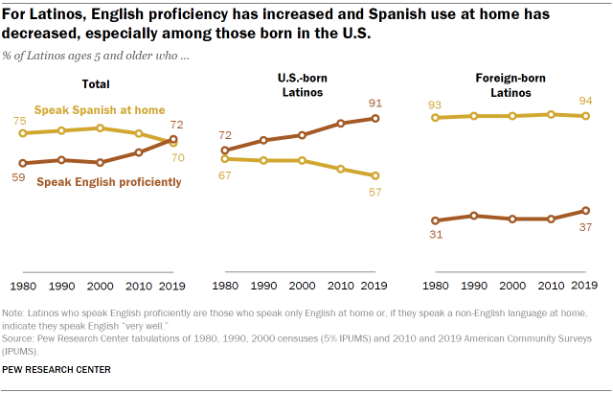
Changes in language use have been more pronounced among U.S.-born Hispanics. In 2019, 91% spoke English proficiently, up from 72% in 1980. Meanwhile, the share that speak Spanish at home fell, to 57% in 2019 from 67% in 1980. By contrast, changes in language use among Hispanic immigrants is mixed. English proficiency is up: In 2019, 37% spoke English proficiently, a jump from 31% in 1980. At the same time, Spanish use at home remains high: 94% of Hispanic immigrants spoke Spanish at home in 2019, about the same as in 1980.
_____________________________________________________________________________________

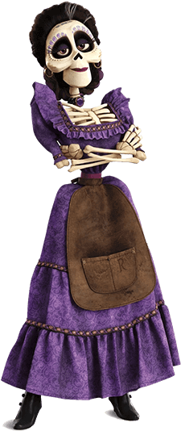
Mexican Traditions in Movies
Imelda from Coco
In 2014, 20th Century Fox released The Book of Life which focuses on the Day of the Dead and includes imagery related to this celebration. In 2017, Disney released its own film based on this Mexican tradition with Coco. The next year, Coco won the Academy Award for Best Animated Film. The popularity of the film helped solidify the presence of the calaveras in popular culture.

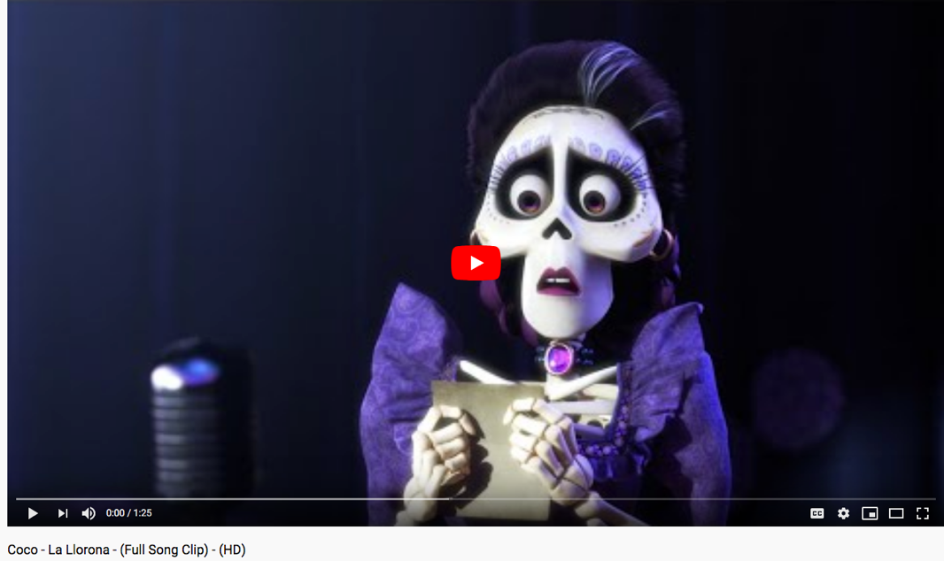
In this clip from Coco, during which Imelda, the ancestor of the film’s protagonist, sings the song, La Llorona.

Answer the following questions:
- How has the Hispanic/Latino population in the U.S. changed over the last 50 years? Provide at least two details from the article.
- What does the fact that production companies such as 20th Century Fox and Disney are releasing movies that feature Latino characters and customs say about the Hispanic population in the U.S.? How is this reflective of American culture more broadly?

Station 4: U.S. Hispanic Population
Instructions: Use the following materials to answer the questions that follow.
Adapted from: Key Facts About The U.S. Latino Population To Kick Off Hispanic Heritage Month
Rachel Treisman | September 15, 2021 | NPR
https://www.npr.org/2021/09/15/1037358346/us-latino-population-demographic-figures-pew-center-hispanic-heritage-month
The Pew Research Center has been tracking key facts and figures on U.S. Latinos for years. Here are some of the latest highlights:
Note: Pew uses the terms "Hispanic" and "Latino" interchangeably; read more about the uses and meanings of those labels here from NPR.
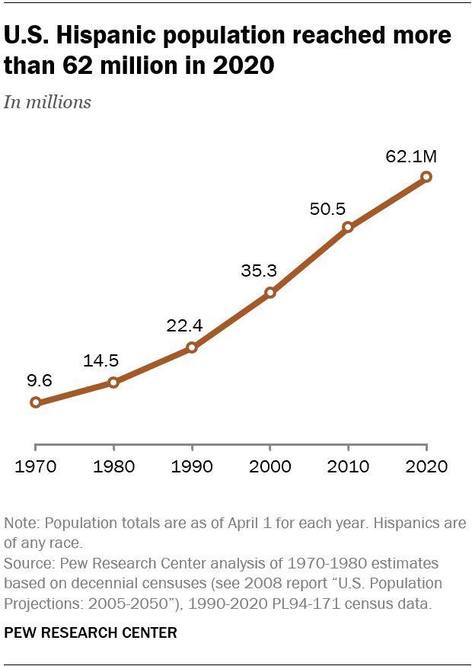
- The U.S. Hispanic population has grown significantly in the last decade, from 50.5 million in 2010 to 62.1 million in 2020. Hispanics accounted for 51% of entire U.S. population growth during that period.
- Four out of five Latinos are U.S. citizens. As of 2019, 80% of Latinos living in the U.S. are citizens. The number includes people born in the U.S. and its territories, those born abroad to American parents and immigrants who have become naturalized citizens.
- The number of Latinos who identify as multiracial has also increased, from 3 million to more than 20 million. This is likely due in part to changes in the 2020 census form.
- All 50 states and Washington, D.C., have seen growth in their Hispanic populations in the last decade. This is especially true for Florida, California and Texas, which saw increases of more than 1 million between 2010 and 2020. North Dakota and South Dakota have seen the fastest growth in their Hispanic populations during this time, though they are still among the smallest in the country.
- Newborns are driving much of this Hispanic population growth, as immigration declined between 2010 and 2019. This is a reversal of historical trends.
- The share of Latinos in the U.S. who speak English proficiently is also growing. Some 72% of Latinos ages 5 and older spoke English proficiently as of 2019. Meanwhile, the share of Latinos who speak Spanish at home has declined (but the actual number has grown).
- The share of U.S. Hispanics with college experience has increased since 2010. The number of Latinos enrolled in college also increased from 2010 to 2019, from 2.9 million to 3.6 million.
- People of Mexican origin made up almost 62% of the country's overall Hispanic population as of 2019. The next largest group is those of Puerto Rican origin. The fastest population growth among U.S. Latinos has come among those with origins in Venezuela, Guatemala and Honduras.

______________________________________________________________________________
Mexican Traditions in Movies
Imelda from Coco
In 2014, 20th Century Fox released The Book of Life which focuses on the Day of the Dead and includes imagery related to this celebration. In 2017, Disney released its own film based on this Mexican tradition with Coco. The next year, Coco won the Academy Award for Best Animated Film. The popularity of the film helped solidify the presence of the calaveras in popular culture.
In this clip from Coco, during which Imelda, the ancestor of the film’s protagonist, sings the song, La Llorona.

Answer the following questions:
- How has the Hispanic/Latino population in the U.S. changed over the last 50 years? Provide at least two details from the article.
- What does the fact that production companies such as 20th Century Fox and Disney are releasing movies that feature Latino characters and customs say about the Hispanic population in the U.S.? How is this reflective of American culture more broadly?
Calavera Skull Activity Possibilities
Some of the best opportunities for education are integrative—meaning that students are able to make connections across disciplines to reinforce the knowledge that they are developing. For example, they may be learning about Renaissance Italy in World Studies at the same time that they read Dante’s Inferno in English class while also studying Botticelli in Art. Feel free to combine and adapt some of the ideas across disciplines and standards to best suit your particular context. You can also collaborate with other teachers at your school or supplement the resources provided by contacting your librarian.
Note: The following ideas are meant to give general guidance for teachers to include artifacts and other material culture in their classrooms. They are not meant to be treated as comprehensive activities or lessons that are one-size-fits-all for any classroom. They should be personalized to best fit the needs of a teacher’s individual context in accordance with prior student learning, student abilities, available resources, and any curriculum.

Art
Visual Arts – Responding:
Anchor Standard 7: Perceive and analyze artistic work
Enduring Understanding: Individual aesthetic and empathetic awareness developed throughout engagement with art can lead to understanding and appreciation of self, others, the natural world, and constructed environments.
Essential Question(s): How do life experiences influence the way you relate to art? How does learning about art impact how we perceive the world? What can we learn from our responses to art?
VA:Re7.1.1a | Select and describe works of art that illustrate daily life experiences.
VA:Re7.1.3a | Speculate about processes an artist uses to create a work of art.
VA:Re7.1.6a | Identify and interpret works of art or design that reveal how people live around the world and what they value.
VA:Re7.1.Ia | Hypothesize ways in which art influences perception and understanding of human experiences.
VA:Re7.1.IIa | Recognize and describe personal aesthetic and empathetic responses to the natural world and constructed environments
VA:Re7.1.IIIa | Analyze how responses to art develop over time based on knowledge of and experience with art and life

Visual Arts – Connecting:
Anchor Standard 11: Relate artistic ideas and works with societal, cultural, and historical context to deepen understanding.
Enduring Understanding: People develop ideas and understandings of society, culture, and history through their interactions with and analysis of art.
Essential Question(s): How does art help us understanding the lives of people of different times, places, and cultures? How is art used to impact the videos of a society> How does art preserve aspects of life?
VA:Cn11.1.1a | Understand that people from different places and times have made art for a variety of reasons.
VA:Cn11.1.2a | Compare and contrast cultural uses of artwork from different times and places.
VA:Cn11.1.3a | Recognize that responses to art change depending on knowledge of the time and place in which it was made
VA:Cn11.1.4a | Through observation, infer information about time, place, and culture in which a work of art was created.
VA:Cn11.1.6a | Analyze how art reflects changing times, traditions, resources, and cultural uses.
VA:Cn11.1.7a | Analyze how response to art is influenced by understanding the time and place in which it was created, the available resources, and cultural uses
VA:Cn11.1.8a | Distinguish different ways art is used to represent, establish, reinforce, and reflect group identity
VA:Cn11.1.IIa | Compare uses of art in a variety of social, cultural, and historical contexts and make connections to uses of art in contemporary and local contexts.
VA:Cn11.1.IIIa | Appraise the impact of an artist or a group of artists on the beliefs, values, and behaviors of a society.

By examining the practices and customs associated with El Día de Los Muertos, students may be asked to consider and discuss the ways in which artistic expression is used and plays a major role. Students can examine the artistic design of the sugar skulls (calaveras), the face paint to represent la Catrina, etc.

Social Studies
Grade Contents
K.3.6 | Identify and compare similarities and differences in families, classmates, neighbors and neighborhoods, and ethnic and cultural groups.
1.1.1 | Identify continuity and change between past and present in community life using primary sources. Examples: Clothing, the use of technology, methods of transportation, entertainment and customs; Compare the roles of men, women, and children; ethnic and cultural groups; types of work; schools and education in the community; and recreation
1.3.8 | Compare cultural similarities and differences of various ethnic and cultural groups found in Indiana such as family traditions and customs, and traditional clothing and food
3.3.7 | Compare the cultural characteristics of the local community with communities in other parts of the world.
6.1.10 | Examine and explain the outcomes of European colonization as it impacted the Americas including the cultural exchange between Europe and the Americas.
6.1.19 | Analyze cause-and-effect relationships, keeping in mind multiple causations, including the importance of individuals, ideas, human interests, beliefs and chance in history.
6.1.21 | Form research questions and use a variety of information resources to obtain, evaluate and present data on people, cultures and developments in Europe and the Americas.
6.3.10 | Explain the ways cultural diffusion, invention, and innovation change culture.

Sociology
S.2.1 | Define culture and identify the material and non-material components of culture.
S.2.5 | Identify culture conflict, cultural similarity, cultural diversity.

Ethnic Studies
ES.3.1 | Students identify and explore current traditions, rites, and norms of an ethnic or racial group(s) and how they have or are changing over time
ES.4.1 | Students examine historical and contemporary economic, intellectual, social, cultural and political contributions to society by ethnic or racial group(s) or an individual within a group.
The grade level as well as sociology and ethnic studies standards listed here all deal with understanding and examining cultural customs. The exploration of El Día de Los Muertos revolves around better understanding the cultural traditions of those who celebrate the holiday, as well as understanding the ways in which the traditions have been formed from the mixing of cultures, and how this celebration reflects beliefs and values of the culture.
World History and Civilizations
WH.4.5 | Explain consequences of the conquests and colonization as a result of the worldwide voyages of exploration including the transatlantic slave trade, Columbian Exchange, and the effects on native populations in the Americas.
The study of El Día de Los Muertos involves the discussion of the impact of European colonization as the holiday is a result of the mixing of Mesoamerican traditions with European/Spanish culture.

Language Arts
Reading:
3.RL.2.2 | Recount folktales, fables, and tall tales from diverse cultures; identify the themes in these works.
4.RL.2.2 | Paraphrase or summarize the main events in a story, myth, legend, or novel; identify the theme and provide evidence for the interpretation.
4.RL.4.2 | Compare and contrast the treatment of similar themes and topics and patterns of events in stories, myths, and traditional literature from different cultures.
Students could examine the themes/morals of the folktale included in the stations activity. Teachers could have students explore a variety of folktales of different cultures including the ones from Afro-Colombian culture that are included in the Digital Toolbox materials.
Writing:
4.W.5 | Conduct short research on a topic.  - Identify a specific question to address (e.g., What is the history of the Indy 500?).  - Use organizational features of print and digital sources to efficiently locate further information.  - Determine the reliability of the sources.  - Summarize and organize information in their own words, giving credit to the source  - Present the research information, choosing from a variety of formats.
5.W.5 | Conduct short research assignments and tasks on a topic.  - With support, formulate a research question (e.g., What were John Wooden’s greatest contributions to college basketball?).  - Identify and acquire information through reliable primary and secondary sources.  - Summarize and paraphrase important ideas and supporting details, and include direct quotations where appropriate, citing the source of information.  - Avoid plagiarism and follow copyright guidelines for use of images, pictures, etc.  - Present the research information, choosing from a variety of sources.
Students could conduct brief research projects on other death rituals and celebrations. They also could conduct research projects other aspects of Mexican and Latin American culture.

