

|  |  |
| --- | --- |
| **Introduction** | |
| Hanbok  Hanbok is the traditional clothing of Korea. Hanbok are characterized by vibrant colors, graceful lines, and elegant design. During this lesson students will learn about Hanbok garments (vestimenta) while reviewing adjectives and colors in Latin. | |
| **Indiana Standards Connections:**  Indiana Classical-Modern Language Standards (revised 2019)    Mode: Interpretive    Standard: Novice Low (first 135 hours of instruction) | **Compelling Question(s):**    How would you describe this garment?  What type of garment is a Hanbok? |
| **Lesson Objectives:**  Students will learn and use descriptive words in Latin like longus, -a, -um; brevis, breve, etc.  Students will learn and use colors in Latin like: caeruleus, -a, -um; rubra; viridis, viride; flavus, -a, -um.    Students will recall basic Roman Numerals. | |
| **Materials** | |
| 1. W2W website link: <https://w2w.indiana.edu/explore-collections/hanbok.html> 2. Latin Colors Handout 3. Hanbok Pingete a Numeris Handout | |
| **Learning Plan** | |
| **Activities**   1. First, the teacher will display the image the Korean Hanbok. Teacher will ask questions in the target language such as:   “Quid est?” - What is this?  “Unde?” - From where do you think this garment originates?  “Quis vestimentum gerit?” - Who wears this garment?  “Quid colores videtis?” - What colors do you see?   1. Next, teacher will pass out the Hanbok coloring sheet. Students will color the Hanbok in “Paint by Number” style using Roman Numerals. Teacher can handwrite the Roman Numeral in pencil, the students can ease the Roman Numeral for a cleaner composition. 2. For more advanced students, teacher may direct them to add flowers, stripes, etc. to the Hanbok. | |
| **Assessment Suggestions**  The worksheet can be used as an informal worksheet - a quick assessment.  The worksheet can also be used as a formal assessment. Simply, provide the students with more colors than the worksheet requires and they need to choose the correct colors! | |
| **Extensions**  Extension I - Classes can compare Korean Hanbok garments to Roman *stolae* and *togae*.  Extension II - Imagine you're writing a travel blog post about South Korea. You want to describe a beautiful hanbok you saw on display. Using vivid details about the colors, fabrics, and design elements, paint a picture with your words so readers can visualize this traditional garment.  This question sparks creativity and encourages students to use descriptive language to depict the hanbok. They'll need to consider various aspects like:   * **Colors:** Are they vibrant or muted? Symbolic? * **Fabrics:** Is it silky and flowing or sturdier with texture? * **Design elements:** Does it have intricate embroidery or clean lines? Unique patterns? * **Overall impression:** Does it evoke elegance, festivity, or something else?   By crafting a word picture, students actively engage with the visual aspects of the hanbok, promoting deeper understanding and appreciation. | |

 Teacher’s Notes

(from W2W website):

“Women’s hanbok consists of two main parts: the *jeogori*, which is a jacket or blouse, and the *chima*, which is a skirt. The *jeogori* is typically short and has a loose fit, with wide sleeves and a rounded collar. It is often adorned with intricate embroidery or patterns. The *chima* is a high-waisted, full skirt that flows gracefully to the ankles. It is typically pleated and secured with a wide sash called a *goreum*.

For men, hanbok consists of the *jeogori*, which is longer than women’s *jeogori*, and *baji*, or trousers. *Baji* are wide-legged and roomy, and are tied at the waist and ankle with a string. *Joggi* (vest) or *durugami* (robe) can also be added on top of *jeogori* and *baji*.”

Worksheet I - Pingete a Numeris

Pingete Hanbokem!

Color each part of the Hanbok according to the Roman Numeral provided!

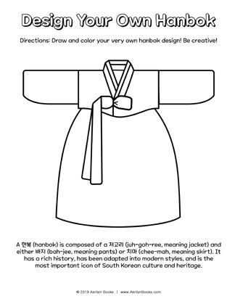

I. Caeruleus II. Rubra III. Viridis IV. Flavus

Latin Colors Handout

