

*Exploring Ancient Innovations: Justice Cups*

|  |  |
| --- | --- |
| **Introduction** | |
| Justice cups are a type of ancient cup designed to ensure fairness and honesty, often used in historical contexts for symbolic or practical purposes. Two well-known examples of justice cups are the Chinese justice cup and the Pythagorean cup, each originating from different cultures and employing unique mechanism to achieve similar goals of ensuring fair distribution or behavior. | |
| **Indiana Standards Connections:**   * 7.H.15 Compare and contrast perspectives of history in Africa, Asia, and the Southwest Pacific using fictional and nonfictional accounts, including visual, literary, art, and musical sources. * 7.G.1 Formulate a broad understanding of the location of countries within Africa, Asia, and the Southwest Pacific. * 7.G.2 Describe and compare major cultural characteristics of regions in Africa, Asia, and the Southwest Pacific. * 7.G.6 Describe the limitations that climate and landforms place on land or people in regions of Africa, Asia, and the Southwest Pacific. | **Compelling Question(s):**   * What role did Chinese justice cups serve in ancient Chinese legal proceedings? * What is the symbolism and significance of the intricate designs on Chinese justice cups? * How do Chinese justice cups reflect the values and beliefs of ancient Chinese society? |
| **Lesson Objectives:**  Students will learn about Chinese justice cups, their historical significance, symbolism, and cultural importance within Chinese society, while also understanding their contemporary relevance. | |
| **Materials** | |
| 1. Images showing Huichol rukuri craftsmanship from the Windows to the World website. <https://w2w.indiana.edu/explore-collections/justice-cup.html> 2. Samples of Huichol rukuri artworks (if available) 3. Paper and writing utensils 4. Internet access for research 5. Art supplies for optional project | |
| **Learning Plan** | |
| **Activities**  *Opening:*  Show students images of Chinese justice cups from the Windows to the World website. Ask “What do you think these cups were used for in ancient China? Why do you think they were important in Chinese history?”  *Introduction to New Material:*   * Discuss the history of Chinese justice cups, focusing on their use in judicial practices and cultural significance. * Emphasize the intricate designs and symbols found on Chinese justice cups to highlight their importance. * Address the common misconception that Chinese justice cups were simply decorative items without practical use in ancient China.   *Guided Practice:*   * Distribute pictures of different Chinese justice cups and ask students to identify and explain the symbolism behind the designs. * Provide examples of legal cases where Chinese justice cups were used and discuss their impact on the outcomes. * Monitor student understanding through questioning, starting with basic recall and progressing to deeper analysis of the cultural implications of Chinese justice cups.   *Independent Practice:*   * Ask students to research and write a short essay on the role of Chinese justice cups in ancient Chinese legal systems. * Encourage students to include specific examples and explain how Chinese justice cups reflected the values of Chinese society during that time.   *Guided Practice:*   * Introduce students to the idea that justice cups like the ones used in China are used around the world in various forms. * Show video from YouTube about the functi9on of Pythagorean cups.   + <https://www.youtube.com/watch?v=ZUxhX-RS_5U> * Analyze the scientific principles behind Pythagorean cups. * Compare and contrast the design and functionality of Chinese justice cups and Pythagorean cups.   *Closing:*   * Have student share their key findings from the independent practice activity to summarize the lesson and reinforce learning. | |
| **Assessment Suggestions**    Create a presentation explaining the history and purpose of Chinese justice cups and conduct a group discussion on their importance in Chinese history. | |
| **Extensions**    For students who finish early, provide materials for them to create their own model of a justice cup or Pythagorean cup using everyday materials like paper cups, straws, and tape. (see attached) | |

**Technology: Pythagoras Cup!**

**Ages: 7 - 13**

Hello everyone. This is Bill from the Okanagan Regional Library System. Welcome to the fun and inventive world of making STEAM projects in your own home. Each week, I will share a fun and interesting project that you can make using materials commonly found in your own home.

Even though we can’t be together right now, we can still learn how to make exciting projects each week!

This week’s project: How to Make a Pythagoras Cup.

**Pythagoras Cup**

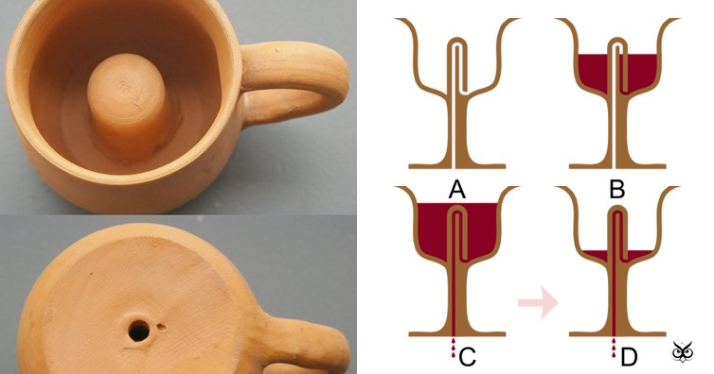

This strange looking contraption is named after the Greek mathematician Pythagoras, who lived 2000 years ago.

Pythagoras’s cup was designed to catch greedy people who tried to take more than their fair share of wine. When filled above a certain point, the cup drains the liquid (in this case, water) through its base. It works because a liquid will always flow from an area of high pressure to an area of low pressure – an effect known as a siphon.

This activity can be a bit complicated, but the results are worth it. Be patient and follow the directions carefully. To make the Pythagoras cup, you will need to use a lot of plastic. Make sure you recycle it once you are finished.

**Materials Needed:**

* 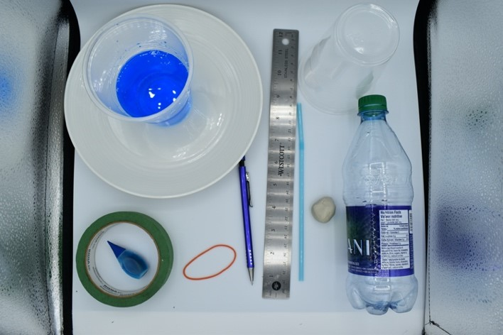Pencil
* Masking tape
* Bendy Plastic Straw
* Food Colouring
* Cup of water
* Scissors
* Ruler
* Rubber Band
* Adhesive putty
* Colored Tape
* Plastic Cup
* Plastic Bottle
* Dish

**Time:** 1 hours

**Steps:**

* 1. Cut around the bottle, about 7 cm from the top, and keep the top part. Cover any sharp or uneven parts of the cut edge with the tape.

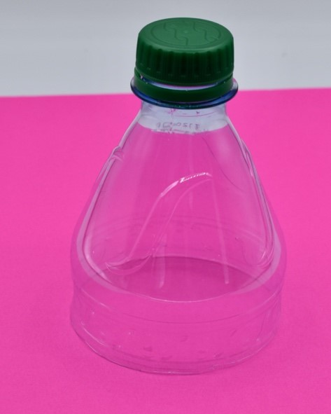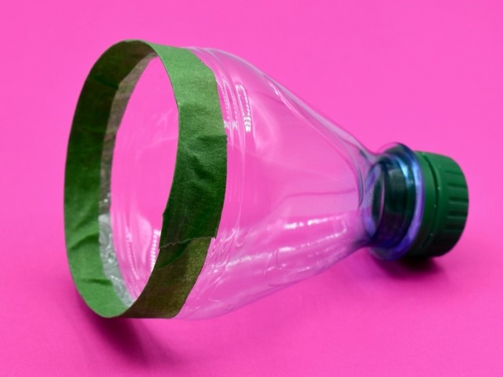

* 1. Remove the bottle’s cap and use the scissors to make a hole in the middle of it.



* 1. Press a lump of adhesive putty on top of the cap. With the scissors, make a hole in it, to line with the hole in the cap.

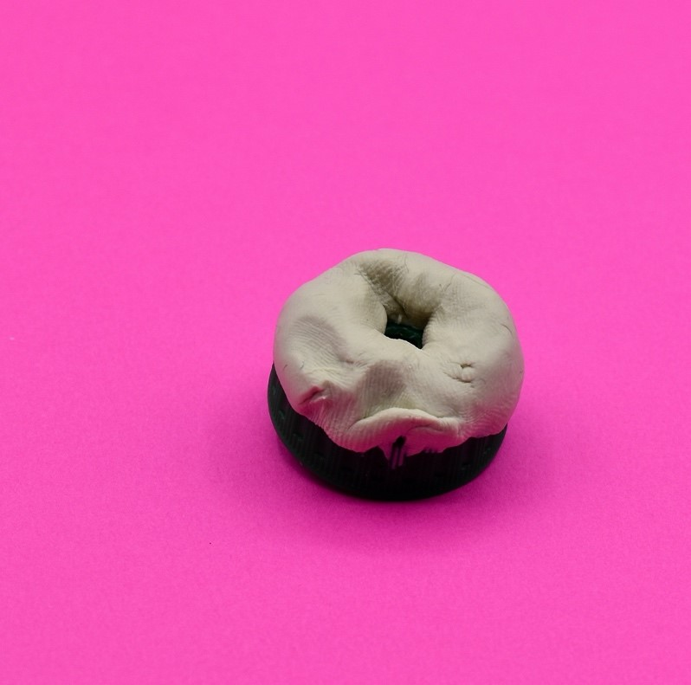

* 1. Cut about 2 cm off the end of the straw farthest from the bendy end part. Fold the straw at its bendy end part and secure it in place by wrapping it with the rubber band. Make sure that you don’t pinch the bend in the straw.

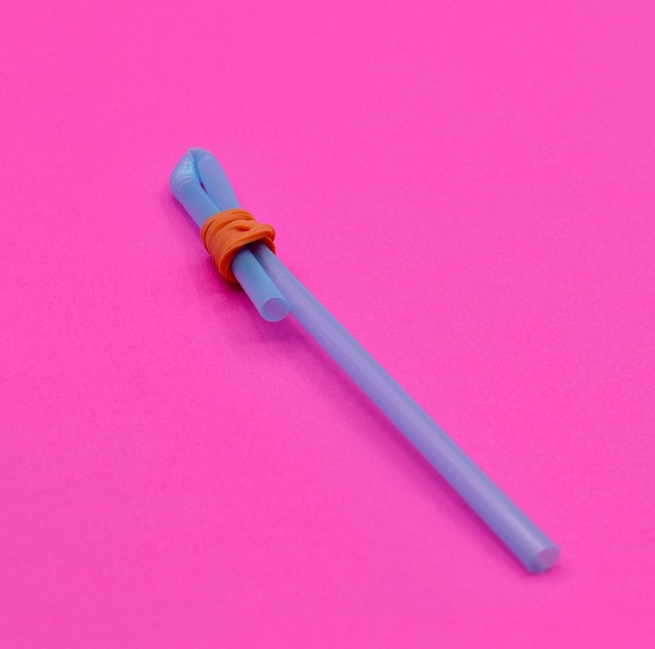

* 1. Make a hole in the middle of the bottom of the plastic cup.

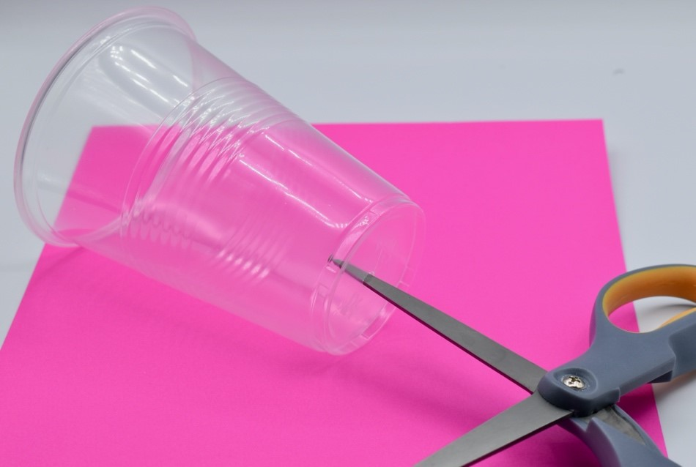

* 1. Feed the long end of the straw through the hole in the plastic cup, making sure that the folded part is inside the cup.

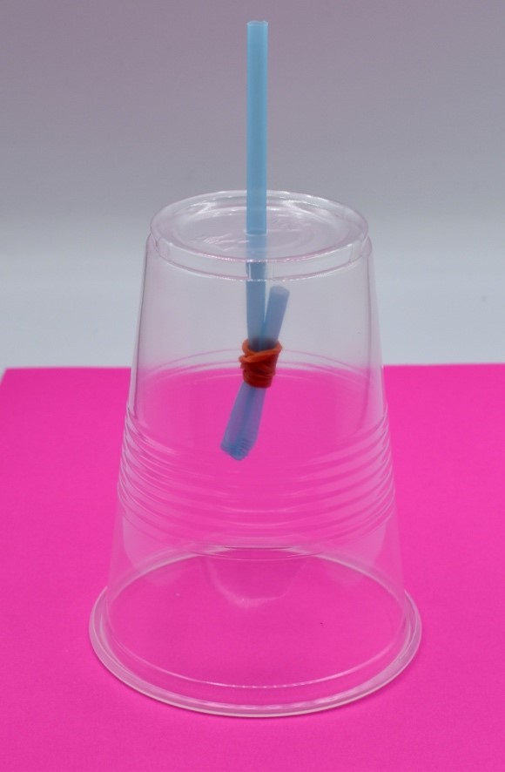

* 1. Push the long end of the straw through the hole in the adhesive putty and the bottle cap.

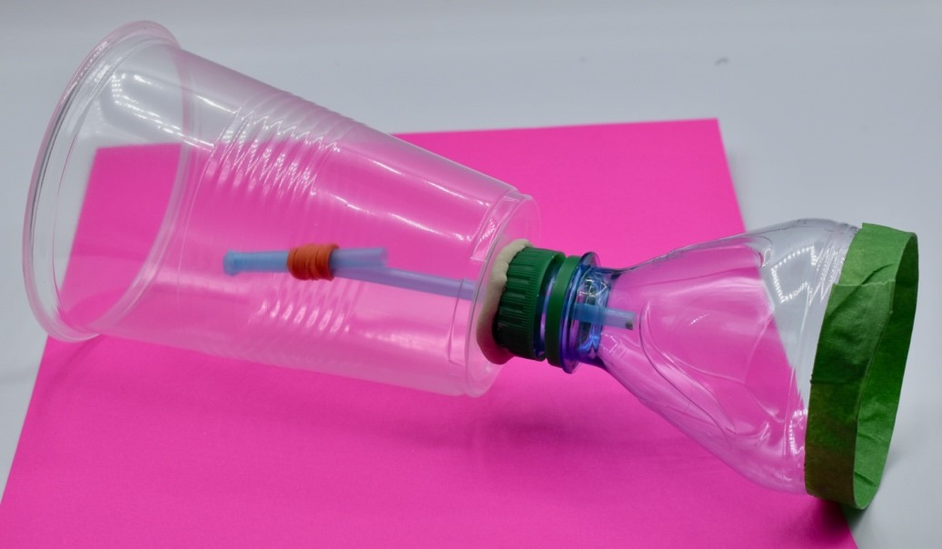

* 1. Push the adhesive putty on the bottle cap onto the bottom of the plastic cup. Use a pencil to pack some more adhesive putty around the straw on the inside of the plastic cup and the inside of the bottle top.

* 1. Pour some food coloring into the cup of water. Stand the Pythagoras cup inside the dish. Begin pouring the water into the cup.

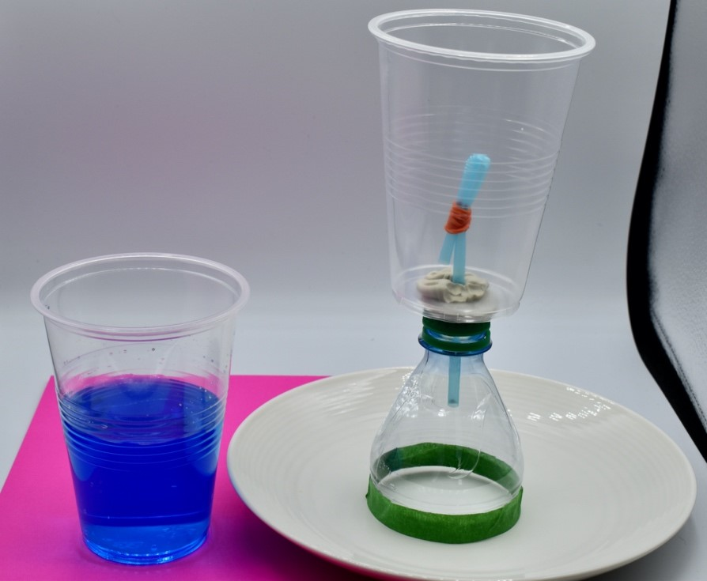

* 1. The cup will fill up until the level of the water reaches above the top of the straw. When it does most of the water will leak out. Test and Tweak.

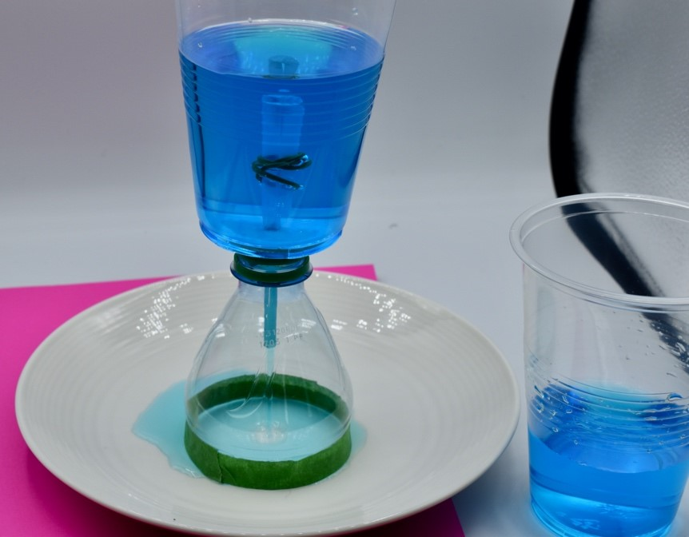

# The Science behind your Pythagoras Cup

When you are filling the cup, water climbs up the straw, pushed by the pressure of the water, which increases as more water is poured in. When the water level in the cup is greater that the height of the straw, the water pressure pushes the water over the top of the bent part of the straw. The water keeps flowing, because the pressure at the bend in the straw remains lower than the pressure at the open part of the straw inside the cup. This effect is known as a siphon.

# STEAM

This activity includes everything you need for a comprehensive STEAM project.

**Science:** Understanding the effects of water pressure.

**Technology:** Understanding how a siphon works.

**Engineering and Art:** Construction of the Pythagoras Cup.

**Math:** Measuring water displacement, measuring and cutting out the parts needed to construct the Pythagoras Cup.