Medal of Cosimo II Duke of Tuscany

Introduction
Through the creation and managing of the Medici Bank the Medici family rose to power in 15th century Italy. In addition to bankin,g they are known for their highly influential commissions of art and architecture.

Indiana Standards Connections:  1C.1I.NL.a - I can provide information by answering a few simple questions on very familiar topics, using practiced or memorized words and phrases, with the help of gestures or visuals.  WH.7.2 Locate and analyze primary sources and secondary sources related to an event or issue of the past. | Compelling Question(s):  Who was Cosimo II?  How were medals displaying portraits used and why were they commissioned?
Lesson Objectives:
Students will examine a medal commissioned in the Renaissance in Italy.
Students will make connections between the elements of the medal and the person/family portrayed on it.
Students will, if they are students of Latin, translate the title on the medal.
Materials
Link to website:
https://w2w.indiana.edu/explore-collections/medici-medal.html

Worksheet (included in this document)
Teacher’s Notes (included in this document)

Learning Plan
Activities
- Instructor shows the image of Cosimo II’s Medal from W2W website.
- Instructor asks students to examine the coin.
Questions may include:
  - Can you guess what country this medal is from? Why?
  - Can you guess who this person was or what their occupation was?
  - What can you tell from the material from which you think it was made.
- Instructor leads students to translate the Latin on the coin. A key is provided here for instructors who do not know Latin.
- Supplemental information about Cosimo II, the Medici Bank, and the materials for this coin possibly being purchased in Africa.
Assessment Suggestions

Formal assessment could include a multiple choice/matching section with facts about Cosimo II.
Formal assessment could also include a reproduction of a medal and students identify the characteristics.
Informal assessment could include a medal the students create with their likeness or the likeness of someone they admire.
Extensions
This lesson can be expanded by exploring Cosimo I (comparing medals, coinage, and/or art commissions).
This lesson can also be expanded by examining Cosimo II’s professional and personal relationships (e.g. Galileo Galilei).

TEACHER’S NOTES
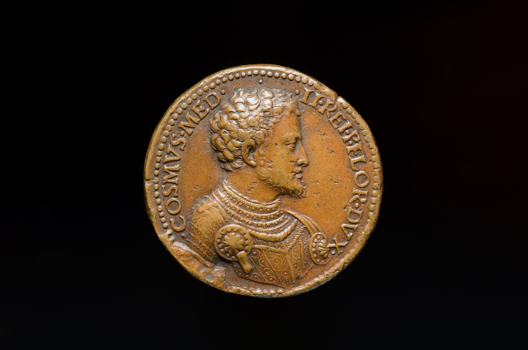
https://w2w.indiana.edu/explore-collections/medici-medal.html
- Copy the letters and words you can see on this medal:
(Students decipher the letters and try to copy them in the space below).

- Now refer to this abbreviation guide:
  - COSIMUS = Cosimus
  - MED = Medici
  - REI = Res, rei f. thing, account affair + public = republic
  - P = Publicus (combined with res = “republic”)
  - FLOR = Florentia (Florence, modern-day Firenze)
  - DUX = Dux, ducis, m. leader

III. Next, translate this medal’s Latin titles. Cosimo II Leader of the Republic of Florence

IV. What do we understand about Cosimo II from seeing this medal alone?
- leader
- rich enough to have a medal commissioned
- medal, not a coin, so it wasn’t used as currency to buy/sell goods
- might be from a powerful family because he is the “II.

Nomen (name)_______________________________________ Hora (hour)_____
A Renaissance Medal
https://w2w.indiana.edu/explore-collections/medici-medal.html
- Copy the letters and words you can see on this medal:

- Now refer to this abbreviation guide and translate if you can:
  - COSIMUS = Cosimus
  - MED = Medici
  - REI = Res, rei f. thing, account affair + public = republic
  - P = Publicus (combined with res = “republic”)
  - FLOR = Florentia (Florence, modern-day Firenze)
  - DUX = Dux, ducis, m. leader

IV. What do we understand about this person from seeing this medal alone?

