Taking a Stand: Using Evidence to Support a Claim about Social Issues

Introduction
This lesson uses objects to provoke students into thinking about the morality of particular issues related to the UN’s sustainable development goals. Students will be exposed to authors who have taken a stance on the issue and discuss their claims and evidence. Students will take a side and debate.

Indiana Standards Connections:  5.RN.4.1 Explain how an author uses reasons and evidence to support claims in a text, identifying which reasons and evidence support which claim.  5.RN.4.2 Combine information from several texts or digital sources on the same topic in order to demonstrate knowledge about the subject.  5.ML.2.1 Review claims made in various types of media and evaluate evidence used to support these claims.  5.RN.2.1 Quote accurately from a text when explaining what a text says explicitly when drawing inferences.  5.RN.3.1 Apply knowledge of text features in multiple print and digital sources to locate information, gain meaning from a text, or solve a problem.  5.RN.3.3 Analyze multiple accounts of the same event or topic, noting important similarities and differences in the perspectives the accounts represent.  5.SL.2.1 Engage effectively in a range of collaborative discussions (one-on-one, in groups, and teacher-led) on grade-appropriate topics and texts, building on others’ ideas and expressing personal ideas clearly.  5.SL.2.2 Reflect on and contribute to ideas under discussion by drawing on readings and other resources. | Compelling Question(s):  How do authors support their claims?  How can you use evidence to support your claim?  What are the multiple perspectives of social issues?  - Are zoos ethical?  - Should we use plastic?  - Should we have school uniforms?
Lesson Objectives:
Students will be able to read texts from a variety of perspectives and collect evidence to support their claim.

Materials
Slide show with pictures and links to articles.
Post its
Paper to collect notes
Should There Be Zoos? A Persuasive Text by Tony Stead

Learning Plan
Activities
Provocation: Invite students to go through the SEE, THINK, WONDER routine with the ostrich egg. Share with students the history connected to the egg. Show them the Tower of London Menagerie sight and explain how colonization and globalization led to the beginning of zoos.

Pose the question: Are zoos ethical?

Have students create a t-chart, turn and talk, and record their initial response to the question.

The next day, read articles in support of zoos. Have students add to their “yes” side. The following day read articles against zoos. Students add notes to the “no” side.

On the fourth day, students will place a post it note on the side they want to defend. Have students group up with other students who agree with them and share evidence with each other. Every student is responsible for giving one piece of evidence. After the other side presents their evidence, open the floor up for rebuttals.

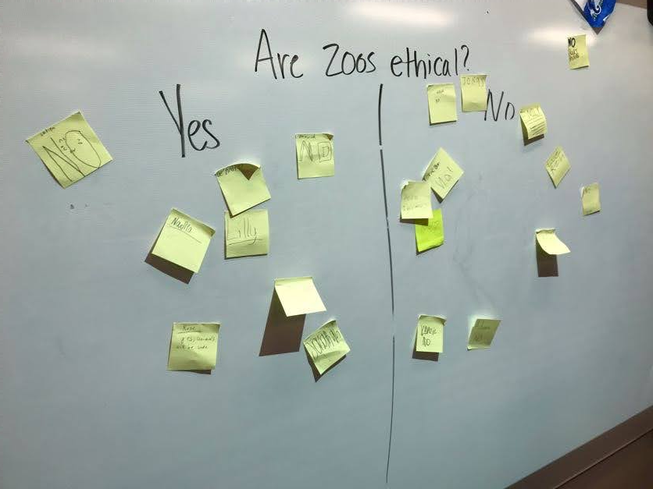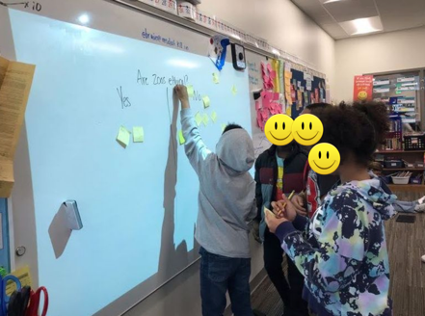

Variations: Have students choose a side and only read (or find) articles that support their choice. Have student partner up to debate. Have students write their argument in a persuasive essay.

Repeat the process with the Gallimoto (Should we use plastic?) and the Ghaghra skirt (Should schools enforce uniforms?).

Assessment Suggestions
Collect student t charts to see that they have collected evidence to support their side.
Make observations and record proficiency during the debate.
Extensions
Have students choose their own issue related to sustainable development goals to debate.
Have students argue for the opposing view point.
Have students write an essay to defend their position.

