The Achievements of Ancient Rome

Introduction
The early Romans were influenced by other ancient civilizations, such as the Etruscans and the Greeks, in the areas of art, architecture, engineering, law, language, and religion. In turn, many Roman achievements in these areas still have a lasting effect today.
Indiana Standards Connections:  6.1.1 Summarize the rise, decline, and cultural achievements of ancient civilizations in Europe and Mesoamerica.  6.3.4 Describe and compare major cultural characteristics of regions in Europe and the Western Hemisphere.  6.W.3.2 ELA Informative Writing | Compelling Question(s):  How did the Romans use/perfect the achievements of other early civilizations?  What lasting contributions did the Romans make in the areas of art, architecture, engineering, government, and religion?
Lesson Objectives:
Students will be able to describe Roman achievements in the areas of art, architecture, engineering, government, language, and religion as well as describe the modern effects of the legacy of Rome.

Materials
1. Copies of the photo of the bust of Septimius Severus.
2. Copies of the Student Instruction Sheets
3. Copies of the Score Sheet for Roman Achievement Project (1 per student)
4. Copies of the Gallery Comment Card (1 per student)

Learning Plan
Activities
Introduce the lesson with this Photo Provocation Writing Activity
Display the photo of Septimius Severus on the document camera or have several copies at each student table. Instruct the students to study the photo then, in 1-2 paragraphs, answer one of the three writing prompts: 1. Spark a fictional story, 2. Make a social studies connection or prediction, 3. Make a personal connection.
Start a class conversation - students discuss and share their thoughts. After the discussion, briefly describe the subject of the photo.

Introduce the Project Choice List
Walk the students through each of the 5 choices explaining the details of each choice and the time frame to complete the assignment. I gave my 6th-grade students 1 week of class time (50 minutes each day) to complete their projects. This can be adjusted to fit any classroom.

There is a video clip below some of the choices for students to watch before making their decision. The student instruction sheets follow this first page.
- Interview a Famous Roman
Check out the Roman News!
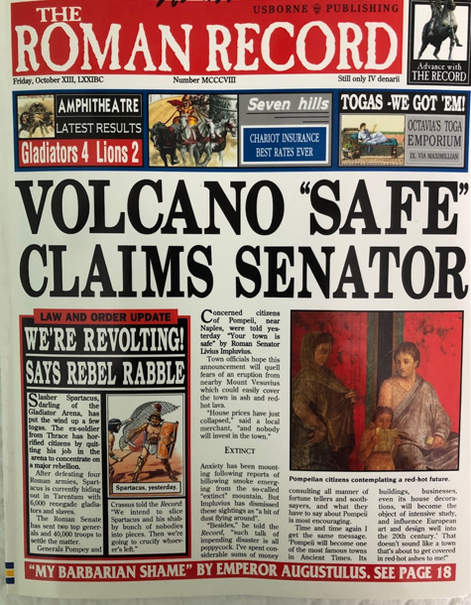
2. Prepare an Advertisement for a Famous Roman Achievement
3. Create a Mosaic
Watch this! The Roman Villa of Casal: Ancient Mosaics in Sicily https://youtu.be/B1FZHy67uU0
4. Design a Postcard for the city of Pompeii BEFORE Mt. Vesuvius Erupted
Watch this video, Mount Vesuvius and Pompeii https://youtu.be/B1FZHy67uU0
5. Sketch/Create a Model for a Famous Roman Achievement
Watch this video about the Roman Colosseum https://youtu.be/rTL0HBSaFw4

Student Instruction Sheets

Choice 1 - Interview a Famous Roman
This is your chance to interview a famous Roman. Is there someone we talked about in this unit you found interesting and would like to learn more about? Maybe one of the "good" emperors or maybe one of the bad ones?
All good journalists gather background information on their subjects, so your first step is to do some research and TYPE a short biography (2 paragraphs should do). Include a list of your sources!
Then, prepare 5 (or more) questions you would ask this person if you could sit down with them for an interview. Good questions are ones for which you don't already know the answer. For example, you might ask Julius Caesar if he regrets crossing the Rubicon River with his army. Does he wish he stayed in Gaul?
This project is worth 20 points. 10 points for the bio paragraph(s), and 10 points for thought-provoking questions (you will not actually answer the questions).
Spelling and grammar count!
Provide a list of sources!

Choice 2 - Prepare an Advertisement for a Roman Achievement
The Romans are known for their many achievements and improvements to those of other civilizations - such as the Roman bathhouses, aqueducts, glassware, concrete, surveying tools, soldiers' armor or weaponry, maybe even a chariot!
Advertisements try to sell something, and good marketing people always research the product they are trying to sell.
Your first step will be to research the achievement you choose and prepare a 1-2 paragraph information piece about it. Provide a list of sources!
Then, create your ad! You might look in magazines to see how the professionals do it! Use your imagination and lots of color!
This project is worth 20 points - 10 points for the info paragraphs and 10 points for the advertisement.
Spelling and grammar count!
Provide a list of sources!

Choice 3 - Create a Mosaic
The Romans loved to decorate their homes with art. Mosaics were common in many households. Here's your chance to create your own mosaic.
You'll need to do some research first and write 1-2 paragraphs explaining this Roman art form. Provide a list of sources!
Then you can create your own mosaic with cut-up colored construction paper.
This project is worth 20 points - 10 points for the informative paragraphs and 10 points for your mosaic.
Spelling and grammar count!
Provide a list of sources!

Choice 4 - Design a Postcard for the City of Pompeii BEFORE Mt. Vesuvius Erupted
The town of Pompeii is quite famous.
Do some research and find out more, write 1-2 paragraphs describing the town. Be sure to include its location in Italy and why it's famous! Provide a list of sources.
Then, create a postcard for Pompeii. Be creative and colorful!
This project is worth 20 points - 10 points for well-written informative paragraphs and 10 points for a colorful creative postcard.
Spelling and grammar count!
Include a list of your sources!
Choice 5 - Sketch/Create a Model of a Roman Achievement
The Romans are known for their many achievements and improvements to those of other civilizations. Maybe you'd like to try building or sketching a Roman achievement, such as the groma, an arch, the Colosseum, or the dome of the Pantheon (there are many more to choose from). It all starts with research!
Your first step is to research the achievement. In 1-2 paragraphs (or more) explain the achievement. Don't forget to list your sources!
Then, either sketch or create the achievement and submit a photo of YOUR creation.
This project is worth 20 points. 10 points for your informative paragraphs and 10 points for your sketch or creation.
Spelling and grammar count!
Provide a list of sources!
Assessment Suggestions
I used the following score sheet for my 6th-grade social studies class. If using the activities for older students or a 6th-grade ELA writing assignment, a more rigorous writing piece and rubric would be more appropriate.
Legacy of Rome Project Score Sheet
Part 1 – Informative Writing
At least 1-2 paragraphs specifically explaining your topic. This is where you use the information gathered from your research. Remember to use your own words and edit for CUPS before submitting a typed essay.
List your Sources
Provide a separate, typed list of the sources you used for your work.
Part 1 Total Points _____/10
Part 2 – Get Creative!
This is the fun part-use your imagination! I’ll be looking for creativity, color, neatness, and correct grammar (if applicable).
Part 2 Total Points _____/10
Project Total _____/20
Follow-up Activity – Gallery Walk
With over 100 students, not every project can make it to the hallway bulletin board (especially the 3D creations). However, every creator should be celebrated! The week following the project due date, I turned the classroom into an art gallery. Projects were displayed on tables along with a comment card (see below). Students walk through the gallery to learn from each other, appreciate great artwork, and offer positive peer reviews.
Comment Card
Thank you for visiting our gallery. We welcome your feedback – please leave kind thoughts and comments for the creators.

Extensions

