Septimius Severus - An Introduction

Introduction
Septimius Severus was a Roman Emperor of African heritage. Born of equestrian rank, he rose to power after a period of political upheaval.

This lesson will introduce students to the heritage of an emperor and his rise to power. Students will develop their translation skills as they read Severus’s biography, a text written in the style of Suetonius - an author included in the typical Latin canon. In addition to a Latin translation students will be introduced to the portraiture styles of the Imperial period.

Indiana Standards Connections:  WH.7.2 Locate and analyze primary sources and secondary sources related to an event or issue of the past.  WH.7.5 Use technology and historical data in the process of conducting and presenting historical research. | Compelling Question(s):  Who was Septimius Severus?  Why was Septimius Severus an important Roman Emperor?
Lesson Objectives:

Students will examine the bust of Septimius Severus on the W2W website to understand the characteristics of Roman Portraiture during the Imperial Period.

Students will analyze a selection of Latin literature - a biography of Septimius Severus from the Historia Augusta and gain a better understanding of Severus’s origins and rise to power.

Materials
The text of the Historia Augusta (Latin and English) is an open source that can be found here: https://penelope.uchicago.edu/Thayer/L/Roman/Texts/Historia_Augusta/Septimius_Severus*.html#1

Link to image:
https://w2w.indiana.edu/explore-collections/bust-of-septimius-severus.html

A worksheet is included in this lesson for teacher and student use.
Learning Plan
Activities
First, the teacher will display the image of Septimius Severus, using the W2W website (See link in Materials. Teacher will ask the students to make guesses about what the bust is communicating - what can we guess about the person?

After the students make guesses the teacher will explain the characteristics of Roman Portraiture during the Imperial Period. Then, as a class, students and teacher will draw arrows and label three characteristics of the piece.

Finally students and teacher together can read about Septimius’s family origins and his rise to power from a primary source. The attached worksheet is in Latin and the English is linked for those who would like it.
Assessment Suggestions

Students can render an English version of the Latin they are reading as a way to assess their translation skills. Students can also be tested on the content of the passage - names of Severus’s ancestors etc.

Students may also be asked to identify an Imperial Portrait in a line-up of Roman portraits. An informal assessment could include a memory game of emperors (based on the experiences of the class).

Extensions

This lesson can be expanded by comparing the bust of Septimius Severus to Republican era images, Judio-Claudian, Flavian, etc. portraiture.

This lesson can also be expanded by examining the year 193 CE - the Year of Five Emperors. Who was vying for power and how did Severus come out on top?

A worksheet for the Latin Classroom

Nomen: ________________________________________Hora: ___________
Septimius Severus

Link to image:
https://w2w.indiana.edu/explore-collections/bust-of-septimius-severus.html

Examine the following image. Roman emperors of the Imperial period combined elements of Greek, Roman, and local (provincial) traditions. Here, we can see Septimius Severus’s display of military prowess and strength in leadership through the use of military dress, beard, and facial features.

- Draw a line and label his military dress.
- Draw a line and label his “philosopher’s beard.”
- Draw a line and label his “ideaslistc” or “never-aging” face.

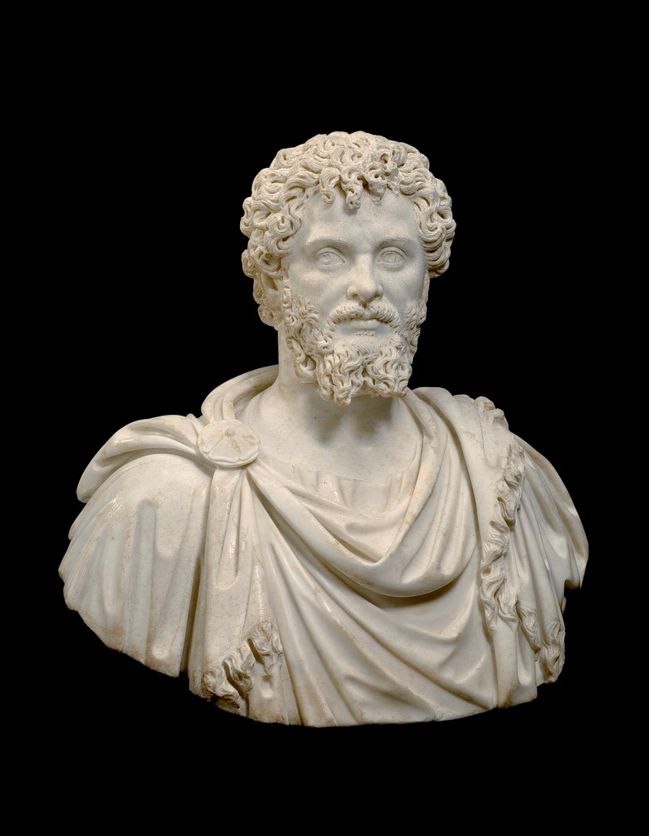

From: Historiae Augustae By: Unknown authors, modeled after Suetonius

Interfecto Didio Iuliano Severus Africa oriundus imperium obtinuit. 2 cui civitas Lepti, pater Geta, maiores equites Romani ante civitatem omnibus datam; mater Fulvia Pia, patrui magni​1 Aper et Severus consulares, avus paternus Macer, maternus​2 Fulvius Pius fuere. 3 ipse natus est Erucio Claro bis et Severo consulibus, VI idus Apriles.

____________________________________________________________________________________________________________________________________________________________________________________________________________________________________________________________________________________________________________________________________________________________________________________________________________
4 in prima pueritia, priusquam Latinis Graecisque litteris imbueretur, quibus eruditissimus fuit, nullum alium inter pueros ludum nisi ad iudices exercuit, cum​3 ipse praelatis fascibus ac securibus ordine puerorum circumstante​4 sederet ac iudicaret.

____________________________________________________________________________________________________________________________________________________________________________________________________________________________________________________________________________________________________________________________________________________________________________________________________________

5 octavo decimo anno publice declamavit.​5 postea studiorum causa Romam venit, latum clavum a divo Marco petiit et accepit, favente sibi Septimio Severo adfini suo, bis iam consulari.
________________________________________________________________________________________________________________________________________________________________________________________________________________________________________________________________________
6 Cum Romam venisset, hospitem nanctus qui Hadriani vitam imperatoriam eadem hora legeret, quod sibi omen futurae felicitatis arripuit. 7 habuit et aliud omen imperii: cum rogatus ad cenam imperatoriam palliatus venisset, qui togatus venire debuerat, togam praesidiariam ipsius imperatoris accepit. 8 eadem nocte somniavit lupae se uberibus ut Remum inhaerere vel Romulum.

____________________________________________________________________________________________________________________________________________________________________________________________________________________________________________________________________________________________________________________________________________________________________________________________________________
9 sedit et in sella imperatoria temere a ministro posita, ignarus quod non liceret. 10 dormienti etiam in stabulo serpens caput cinxit et sine noxa expergefactis et adclamantibus familiaribus, abiit.​

___________________________________________________________________________________________________________________________________________________________________________________________________________________________________________________________________________________________________________________________________________________________________________________________________________
For more on this text: https://penelope.uchicago.edu/Thayer/L/Roman/Texts/Historia_Augusta/Septimius_Severus*.html#1

